Spring Newsletter 2016

Another year passes and our precious lake continues as it has for millennia. But in the past 130 years we’ve added humans to the mix to enjoy and also to challenge it. We are relatively new to the lake and we’ve taken our toll. We’ve built roads and railbeds, built homes on its shores, brought on boats for transportation and fun, cut trees and landscaped in the catchment area, not to mention thrown batteries, refrigerators and all manner of garbage into it – thankfully we don’t do that anymore.

Over the last year your association has spent much of its time educating, advocating, and working for the health of the lake and its community. Along with the Municipal Council and its committees, the focus has been on maintaining and trying to improve the environmental health of the lake and our community.

This environmental focus has taken many forms:

- The Municipal Urban Plan is the cornerstone of these efforts. Many of you answered a questionnaire over the winter that will help to form the plan. It will serve as the foundation on which we go forward with by-laws, expenditures and programs. This spring and summer smaller consultations as well as a larger full community consultation on the Urban Plan will continue. The goal is to have this plan, much of it based on the Biofilia study funded in part by Friends/Amis, in place by the end of the year.

- Last fall we partially funded a milfoil (invasive aquatic plant) study that mapped the weed’s population in our lake. Lac Laurel has been working on similar studies over the last several years. You will have noticed that Hammond’s Bay at the north end of the lake was cordoned off last fall as a pilot project to minimize/prevent the spread of milfoil.

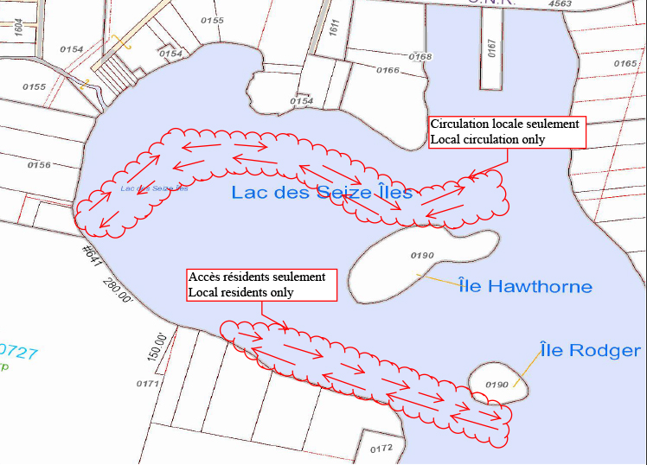
The municipality has contracted a Gatineau-based company to lay a pathway of burlap on the lake bottom in Hammond’s Bay in late June or early July. The burlap will cover the milfoil in
a strip around the north end
of the bay – this path will
be marked by buoys
(see attached map).

Around the beginning of July the weed reaches the water surface in the bay and covers much of it in a thick bed of vegetation over the summer. As engine propellers run through this bed of milfoil the weed is chopped up. It floats all over the lake and ultimately takes root in other parts. The burlap creates a weed-free pathway for local owners to enter and exit the bay towards the municipal docks. To give this program a good chance of success we request that only local property owners or their visitors enter Hammonds Bay. Friends/Amis supports this program and has also partially funded it.

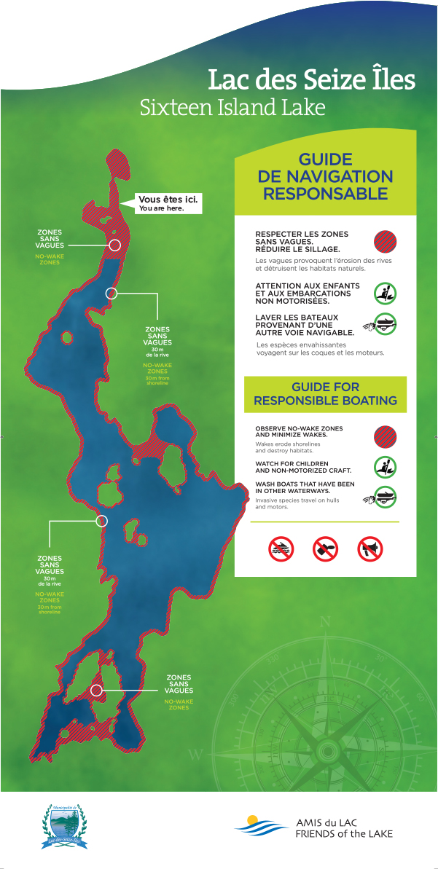
- This summer you’ll notice new signage at the village
boat ramp, the south end and at the Club. The signs
display a map of the lake with “no wake” zones clearly
marked. They also carry commonsense warnings
about boat safety and environmental practices.
Thanks to Tim Boswell for the attractive design and
to Marcel Mcdonald for erecting the signs. These signs
were entirely funded by your association.

Most people observe slower speeds in built up areas
of the lake. This is an obvious safety practice. What is
less commonly observed is wake size in these areas.
Large wakes damage property - boats, docks and
shorelines - natural habitats like loon nesting areas in
the narrows and elsewhere, and the most active
living part of the lake – the shoreline. A slower speed
with a large wake damages all of the above. The idea
is to slow down in designated areas to what’s referred to as “no wake”. Please note that the area in front of the Club is “no wake” as well much of the south end past the narrows. Passing by the Club in Green Bay at higher speed with minimal wake is quite acceptable.

One more thing about boat wakes – not only do they radiate out from a boat but engine propellers also generate great downward force. A recent University of Laval study found that a wakeboard or wake surf boat generates turbulence five meters below the surface – good reason for these boats to be used in deep water and over 100 meters from shore. However, any boat will generate turbulence at varying depths depending on the horsepower and the degree of acceleration of the boat. Who hasn’t gunned it beside a dock in five feet of water when leaving home? The turbulence caused by propeller wash stirs up phosphates from the lake bottom as well as increases turbidity in the water. It’s our lake – let’s look after it.

- Lake access, boat washing and ramps – Counselor Corina Lupu tells us that the boat access regulation is a work in progress. She will organize small informal brain storming meetings to get input. If you wish to participate or host a meeting (maximum five people) please contact her at district5@lac-des-seize-iles.com

- The Dam – Our municipal council and administration are working with all levels of government towards transferring ownership and funding of the repair/replacement of the dam at the south end. There are infrastructure funds available across Canada and our mayor in particular is focused on this project. It has been determined that the dam sits partially on Crown Land which is a major factor. There are thousands of what are referred to as “orphan dams” across Canada so this is not an easy file. If we get funding for this the mayor and our DG in the office deserve a tip of the hat. We’ll know the outcome in the near future.

- Joint projects with the Club – We are funding and working with the Club more than ever this coming year. We are sponsoring or participating in four programs:

The Canadian Loon Survey - We are participating in a Canadian survey of the loon population. Youth from the Club will be counting and monitoring the loon population on our lake – of particular interest are breeding pairs. Last year three chicks hatched but sadly only one survived to the end of the summer. These pairs traditionally hatch in Hammond’s Bay, near Cresswell’s bay and past the narrows towards the south end. Please watch for them in the late spring and early summer – they are particularly vulnerable at these times.

“Motorless Day” – Friends/Amis will host a lunch/barbeque at the Club as well lead some short educational activities. We plan to issue a Green Challenge to Club youth to raise environmental awareness while providing motivation for them to get involved in a broader sense.

Craft Night – We will fund an environmental project for a Club craft night.

Scavenger Hunt – We will work with the Club and Club youth to incorporate an environmental theme to the scavenger hunt list of items to be sought.

- Many of you will know of Jean-Louis Courteau, who has been scuba diving in our lake for the last five years and has discovered many treasures and some abominations (batteries).

Some years ago he found a 500 year old intact Huron vase near the reef off Sesia’s property. It was handed over to the Quebec government and along with other artifacts is on display at Musée de la Pointe-à-Callieres in Old Montreal until January 2017. The following year he found a second vase, broken and 700 years old.

www.pacmusee.gc.ca

This spring Jean-Louis placed small pieces of marble at different locations and depths around the lake. This experiment on the mechanisms of natural underwater erosion is conducted by a renowned University of Ottawa geologist. The results will provide an idea of the age of the lake.

- The Aerobic Corridor – The corridor was officially opened last fall from Morin Heights to St Remi d’Amherst. Plans for this year include a new website to be launched mid June and repairs/improvements to the section from the village to the Route Principale (the paved highway). There are no plans to charge for using the corridor as in the past. Next year after improvements are completed there will be a push to promote the corridor through the village, which leads to …

- Le Station and Resto DCSeize Iles - After many years Jesse at Resto DCSeize Iles has hung up her apron for good. Many thanks to her for all the wonderful times and meals many of us have had there. The end of an era!

And a new era begins. Last fall Karine Miljours and her family began operating Le Station. After a slow start due to the bad winter she looks forward to serving our community’s needs through the summer and over the years. To start the restaurant will open for lunch seven days/week from June 24 through September 5 – currently the restaurant is open Friday, Saturday and Sunday. The fries are wonderful! She is feeling her way at this point and is happy to take any recommendations from her clients. She is a warm, engaging, client service-oriented operator. Karine, her husband and daughter live above the store full-time and are fast becoming a part of the community. Visit her Facebook page:

www.facebook.com/magasingeneral16iles

- Website revamping – We are currently renovating our website and are committed to more current updating of the site. We are hoping to reach a wider audience by posting current items quickly and providing a link to them from other organizations. For instance Club members who are not members of Friends/Amis will be able link from the Club communications to this newsletter. The site will also feature archived items such as videos from the municipal 100th Anniversary celebrations, selected lake photographs and a variety of historical documentation. We hope to be fully up and running by fall.

www.amisdulacdes16iles.org

- Membership – Our membership numbers were at 106 in 2015 – up from 102 in 2014. The three-year membership option began six years ago so Mary has sent out many three-year renewal letters this year. Thanks to all of you for your support over the last year and over all the years – we are a better community with your participation.

- As customary, Tim Boswell provided our association with another wonderful calendar for 2016 – they have become collectors’ items on the lake. Tim is again on the job this spring on the 2017 edition. We are aiming to have them available at our AGM on July 17th.

Where will we find new and interesting photos? From our residents as usual! Thanks to those that have contributed in the past – you’ve contributed to a wonderful tradition. Please help us again by sending your cottage, lake, flora and fauna photos to:

tboswell@cdmmontreal.com

- Our AGM will be held at the Municipal Hall on Sunday July 17th at 1:30 PM. Again there will be a municipal affairs update from Corina Lupu. We look forward to seeing you there

See you all soon

Bill Clelland
President
Friends of the Lake/Amis du Lac

